**Tanks BattleGround**



**Session 2023 - 2027**

**Submitted by:**

Aamir Hashmi 2023-CS-11

**Supervised by:**

Prof. Dr. Muhammad Awais Hassan

& Sir. Laeeq Khan Niazi

**Course:**

CSC-102 Object Oriented Programming

Department of Computer Science

**University of Engineering and Technology**

**Lahore Pakistan**

**Table of Contents**

**1.** **Short Description of Game:** 3

**2.** **Game Characters Description:** 3

**2.1** **Player:** 3

**2.2** **Enemies:** 3

**3** **Rules & Interactions:** 4

**4** **Goal of the Game:** 4

**5** **Object Oriented Concepts:** 4

**6** **Wireframes of the Game:** 5

**7** **Class Diagram(CRC):** 8

**8** **Conclusion:** 9

# **Short Description of Game:**

In this tank war game, players take control of a powerful tank on a mission to defeat all enemy forces. The goal is simple: eliminate every enemy tank on the battlefield to secure victory. But it won't be easy. Players will face three different types of enemies, each with their own unique movement patterns. Whether they're moving vertically, horizontally, or in a zigzag fashion, players must use skill and strategy to outmaneuver and destroy them all. It's a fast-paced, action-packed adventure where every move counts. Are you ready to take command and lead your tank to victory?

# **Game Characters Description:**

# **Player:**

There is one player tank in the Game.

**Tank:**

You're in command of the player tank, the toughest machine on the battlefield. Your tank is big, strong, and loaded with powerful weapons. With easy controls, you can move around and shoot at enemies. Your job is simple: destroy all enemy tanks to win the game and become the hero!

* 1. **Enemies:**There are 3 enemies in the game.
* **Vertical Tank:**This tank moves straight up and down. It's like a robot, always moving forward, so watch out for its steady approach.
* **Zigzag Tank:**The Zigzag Tank is a tricky one. It moves in a zigzag pattern, making it hard to predict where it'll go next. Keep your eyes peeled and be ready to dodge its unexpected moves
* **Teleporting Tank:**

The Teleporting Tank is a tricky one. It moves in a random pattern, making it hard to predict where it'll go next. Keep your eyes peeled and be ready to dodge its unexpected moves.

# **Rules & Interactions:**

Following are the rules and interaction of the game:

* Tank loses a health if he collides with any of the enemy.
* Enemy Tank health decrease when hit by player fire.
* Player Tank health decrease when hit by enemy fire.

# **Goal of the Game:**

The goal of the game is to guide your tank through enemy territory and eliminate all opposing tanks. As you navigate through various levels, you'll encounter different enemy tanks with unique movement patterns. Your mission is to destroy each enemy tank while avoiding getting hit yourself.

# **Object Oriented Concepts:**

***•Inheritance:***Inheritance is used extensively within the framework to encourage code reuse and establish a hierarchy among classes. For example, the ZigZag Movement class and Teleportation class extends the Game Framework Movement Interface to introduce a new type of motion. This approach allows developers to customize object behaviors without needing to modify the core framework code, making the code base easier to maintain and expand.**• Interfaces:**Interfaces define a contract for classes to implement specific functionalities. For instance, the IMovement interface outlines methods for object movement, enabling developers to create custom movement behaviors by implementing this interface. This promotes flexibility and compatibility, as different movement behaviors can be seamlessly integrated into the framework.

**• Singleton Pattern:**The Singleton pattern ensures that only one instance of a class is created, which is useful for managing global game state or resources. In the framework, the Singleton pattern is applied to the Game class to ensure that only a single instance of the game exists at any given time. This prevents unintentional duplication of game instances and simplifies access to game-related functionalities.**• Enumeration:**Enumerations represent a fixed set of named constants, offering a more expressive and type-safe approach to working with data. Within the framework, enumerations are used to define the direction, collision action and type of enemies, enhancing code clarity and maintainability. By leveraging enumerations, developers can easily identify and manage different enemy types and directions within the game.

**• Factory Pattern:**

The Factory pattern ensures that only one limited number of a Players, Enemies and Fires is created, which is useful for managing game state or resources. In the framework, the Factory pattern is applied to the Add Game Object Function to ensure that limited number of Players, Enemies and Fires are created. This prevents unintentional duplication of Game Objects.

# **Wireframes of the Game:**

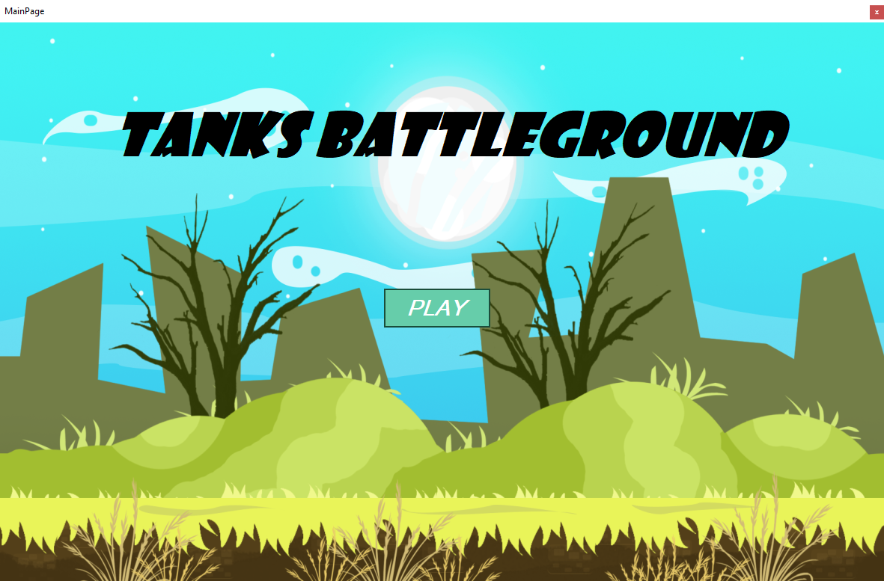

**Game Front Page**

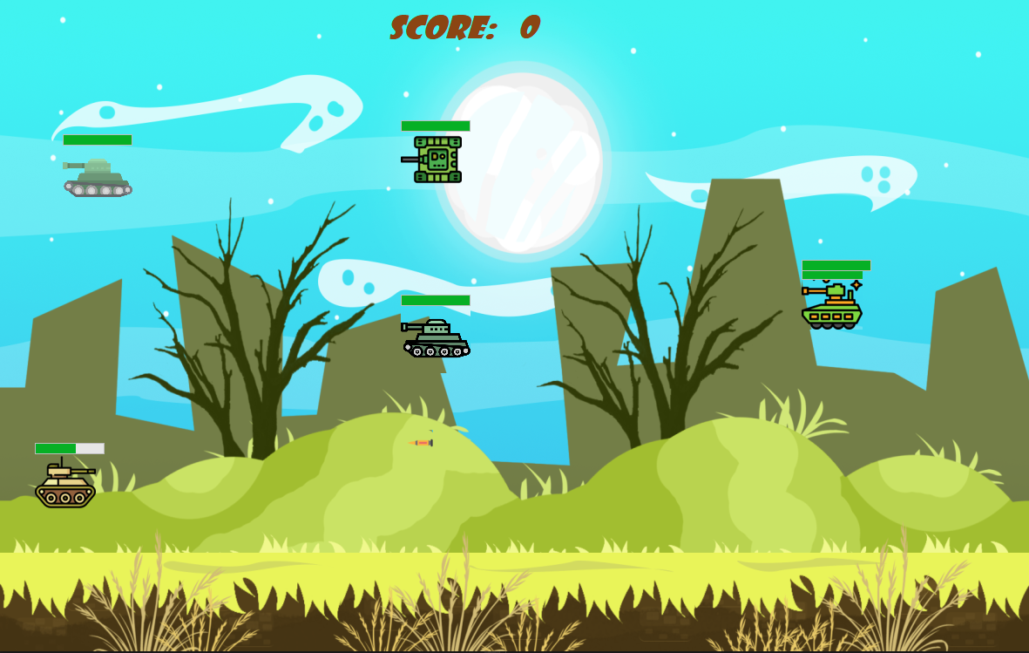

**Game Playing Field**

# **GameOver.PNG**

**Game Over Page**

# **Class Diagram(CRC):**

**GameObject**

- Pb: PictureBox

-Type: GameObjectType

-Health:int

-HealthBar:ProgressBar

+Update():void

**Game**

- FormReference: Form

- PlayerCount:int

- EnemyCount:int

- PlayerFireCount:int

- EnemyFireCount:int

+ addGameObject(Image img,GameObjectType type, int Left, int Top, IMovement controller):void

+update():void

+AddCollisionDetection(CollisionDetection collision):void

+FirePlayer(Image img):void

+FireEnemy(Image img):void

+RemoveGameObject():void

+GetCurrentEnemiesCount():int

+GetCurrentPlayersCount():int

**∞**

**1**

**Contains**

S

1

Has

**CollisionDetection**

- Type1:GameObjectType

-Type2: GameObjectType

-Action:CollisionAction

checkCollision(List<GameObject>gameobjects):void

1

**∞**

Has

1

**IMovement:Interface**

+Move(Point Location):Point

**HorizontalMovement**

- Speed: int

-Boundary: Point

-Direction:Direction

-OffSet:int

**ZigZagMovement**

- Speed: int

-Boundary: Point

-Direction:Direction

-OffSet:int

**KeyBoardMovement**

- Speed: int

-Boundary: Point

-Direction:Direction

-OffSet:int

**VerticalMovement**

- Speed: int

-Boundary: Point

-Direction:Direction

-OffSet:int

# **Conclusion:**

In conclusion, our tank war game is built using a smart approach called object-oriented programming, which helps us organize our code neatly. We use things like interfaces, which are like blueprints for how different parts of the game should behave, and enums, which are like lists of options for certain things in the game.Behind the scenes, we have a strong framework that does a lot of the heavy lifting, like making sure the graphics look good and handling how the game responds to what you do. This framework makes it easier for us to focus on making the game fun and exciting without getting bogged down in technical details.Overall, our game is designed to be easy to play but still challenging enough to keep you hooked. So get ready to take control of your tank, plan your moves carefully, and emerge as the ultimate champion of the battlefield!